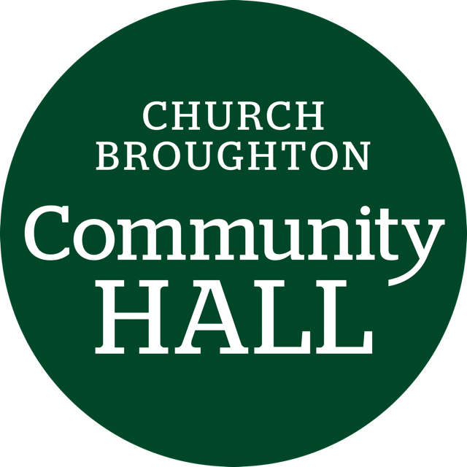
Church Broughton Community Hall Management Committee
AGENDA
14 November 2.00pm

- Welcome and attendance

- Apologies received

- Approval of previous minutes and matters arising

- Incidents reported

- Finance report -Monthly bookings
Revenues
Costs incurred
Remaining budget

- Cleaning rota, regular inspection, risk checks report

- Update from refurbishment group rep

- Electrician booked 17 Nov pm to fix the RCD protection to the two socket circuits and issue a new certificate.

- What is our policy on hirers over-running?

- Arrangement for Christmas Lights Switch-on
  - Dan bringing a string quartet and his trumpet to play from 4.30 for an hour – mostly Christmas Carols.
  - Light switch-on at 5.00
  - Advertising
  - Carol sheets?
  - Finish time – 6.30?
  - Food and drink etc

- Any other business

- Date, time and place of next meeting

