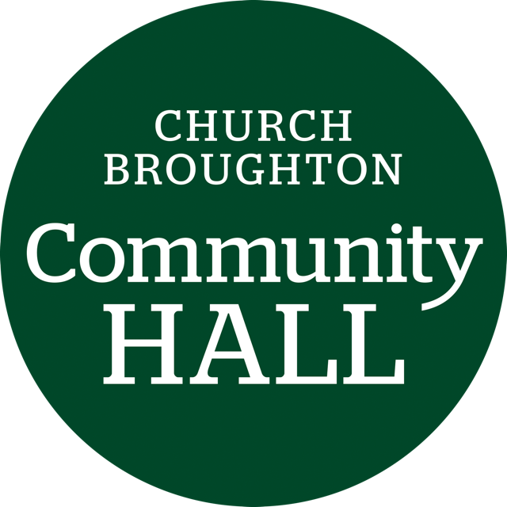

**Church Broughton Community Hall Management Committee**

**AGENDA**

**19 September 2.00pm**

1. **Welcome and attendance**
2. **Apologies received**
3. **Approval of previous minutes and matters arising**
4. **Incidents reported**
5. **Finance report -Monthly bookings**

**Revenues**

**Costs incurred**

**Remaining budget**

1. **Risk assessment**

**Review of fire risk assessment**

1. **Update from refurbishment group rep**
2. **Cleaning rota**
3. **Stop tap**
4. **Review of Regular Inspection / Risk Checks list.**
5. **Village Halls and Community Buildings Affiliate Scheme**
6. **Any other business**
7. **Date, time and place of next meeting**