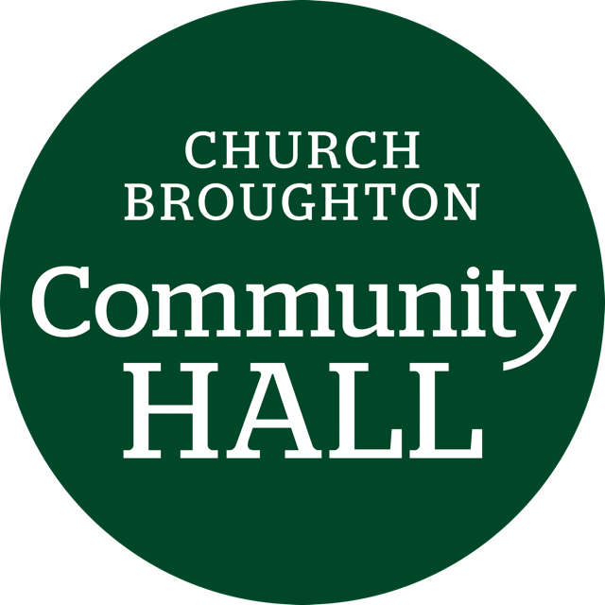
Church Broughton Community Hall Management Committee
AGENDA
Monday November 18th 2024 14.00-16.00pm

- Welcome and attendance

- Apologies received

- Approval of previous minutes and matters arising

- Incidents reported

- Finance report -Monthly bookings
Revenues
Costs incurred
Remaining budget
Electricity
Petty cash

- Review of action plan from previous minutes

- Update from Village Shop rep

- Plan of action after shop closure

- Update from refurbishment group rep

- Any other business

- Date, time and place of next meeting

