CHURCH BROUGHTON PARISH COUNCIL
PARISH COUNCIL MEETING HELD ON THURSDAY 9TH MARCH 2023

Those present: In attendance:
Councillor Pedley-Chairman Helena Steeples-Clerk
Councillor Redfern
Councillor Speake
Councillor Thorpe
Councillor Warriner
Councillor Woodhall

145.0 APOLOGIES
Apologies were received and accepted from DCC Councillor Patten, & SDDC Councillors Lemmon & Smith.

146.0 REPORTS FROM DISTRICT & COUNTY COUNCILLORS & POLICE
Church Broughton Parish Council Report 9th March 2023
SDDC Councillor Gillian Lemmon
SDDC CEO
Frank McCardle who has been in post as CEO for 23 years at SDDC is retiring at the end of this month. Andrew Grant has been appointed as Interim CEO and will be in post from end of March 2023. The permanent position is currently going through the recruitment process.
Council Tax Rise
This has been agreed at Full Council to be a 1% increase for the SDDC element.
Purdah
A reminder that the District Council will be entering Purdah on 23rd March meaning this will be the six week period leading up to the Local Elections.

SDDC Cllr Peter Smith
Light Pollution from Dove Valley Park
can you please encourage any Parish residents that comment or complain about light pollution to report this directly to SDDC Environmental Health Department at: southderbyshire.gov.uk/environmental health
HGV’s using the Woodyard Lane
This has been raised with the site manager and the lead construction company. If any HGV is seen using this entrance could vehicle registration numbers be taken and company name of the vehicle and passed on to us please.
Tree Planting on Dove Valley Park
Cllr Warriner asked about the possibility of some funding for the planting of trees at the back of the DVP site towards the village. I have been speaking with our Chief Exec Frank McArdle frank.mcardle@southderbyshire.gov.uk regarding this, and he’s asked if you (the PC) could write to him (referring to my conversations with Frank), with your ideas and plans (an official letter/email from the PC) and he will endeavour to get all the businesses on the Park to contribute to such a worthwhile scheme. If this could be done as a priority because Frank retires at the end of March.

District and Parish Council Elections on 4 May 2023
Anyone attending a polling station to vote will be required to show an accepted form of photographic identification.
This is designed to reduce voter fraud.
You are not required to provide photo ID for postal voting.
What types of photo ID will be accepted?
The following forms of identification will be accepted:
- Passport issued by the UK, any of the Channel Islands, the Isle of Man, a British Overseas Territory, an EEA state or a Commonwealth country
- Driving licence (including provisional licences
- Biometric immigration documents
- Identity cards bearing the Proof of Age Standards Scheme (PASS) hologram.
- Ministry of Defence Form 90 (Defence Identity Card)
- Blue Badge
- National identity card issued by an EEA state
If your photo ID has expired, it will still be accepted as long as the photograph is still a good likeness of you.
Staff at Polling Stations will not be able to accept photocopies or other pictures of photo ID.
If your name has changed (e.g. through marriage, deed poll etc), you should bring along additional supporting documents, such as a marriage or civil partnership certificate that provides evidence of the name change.
If you have appointed a proxy to vote on your behalf, your proxy must bring their own photo ID to the polling station.
What do I do if I don’t have any photo ID?
If you do not have any of the accepted forms of photo ID, you can apply for a Voter Authority Certificate. Voter Authority Certificates can be applied for by post by downloading the form from Voter ID | Electoral Commission , or online by visiting Voter ID | Electoral Commission.

147.0 PUBLIC PARTICIPATION
None.

148.0 OUTSIDE BODIES PARTICIPATION
None.

149.0 TO RECEIVE & APPROVE REQUESTS FOR DISPENSATION FROM MEMBERS ON WHICH THEY HAVE A DISCLOSURABLE PECUNIARY INTEREST
None declared.

150.0 MINUTES OF THE LAST MEETING HELD 2/2/23.
The minutes of the meeting held on Thursday 2nd February were read, approved and signed. Proposed by Councillor Pedley & seconded Councillor Speake.

151.0 MATTERS ARISING

151.1 COMMUNITY PLAN UPDATE
The Annual Parish Meeting needs to be held between 1st March and 1st June. As there will be Parish Council elections in May it was suggested that the meeting is held before the end of April. Councillor Pedley will speak with the Community Plan Group to arrange a suitable date and then advice Councillors.

King Charles coronation weekend celebrations – Councillor Pedley advised that two or three people from the parish and the Church PCC have offered their services in arranging a village celebration. The VH&PFC have indicated that they do not wish to organise an event but would leave the marquees up from May Day, so they may be used. It is understood that DCC Councillor Patten will be able to access funds of approximately £500 for the parish celebration. Councillor Pedley said that he hoped to arrange for the brass band which he plays with, to come and play on the village park. The band probably would not seek to charge for this but would appreciate a donation towards their expenses. A suggestion is that a picnic is held on the park with the band playing.

151.2 COMMUNITY HALL UPDATE
A proposed income and expenditure plan from the Community Hall Management Committee had been received. Councillors enquired why Wi-Fi at a cost of £400 should be purchased. Councillor Pedley advised that there is a demand for this facility for the shop – presently Mr Lydon has been organising the stock which is now web based and he has indicated he will be stepping down and also transaction payments for customers to the shop. It is hoped that by having Wi-Fi it would encourage more people to attend the pop-up café; soup & pud lunches; and more interest in other functions being held in the building. The Management Committee would like to promote the building; increase usage and in turn create more revenue. It is understood that you are able to sign up for a 2 year WIFI contract and at the end of that period decide if you wish to continue or cancel. Councillor Pedley noted that the expected hall running costs for the year are just about covered by the predicted income.
When viewing the expected capital costs Councillor Pedley confirmed that the sign for the building has been ordered; secondary glazing is expected to be less than the amount stated; it has been decided not to order curtains until renovations have been undertaken and also not to replace the door until later. Capital costs will be covered by cash reserves. The fire risk assessment has taken place and the invoice is on the agenda for payment later in the meeting.
Councillors supported the budget on the proviso that any capital expenditure exceeding £100 would need to come back to the PC for approval. The PC wished the committee to be thanked for all their efforts so far and in the future. Councillors also asked if there were any plans for summer activities e.g. film nights.

151.3 RISK MANAGEMENT
Councillor Warriner enquired if gritting of the ramp was included in a risk assessment. Councillor Pedley advised that it was and a tub containing grit is placed outside the entrance.
No items to add to risk management.

151.4 READING ROOM LAND
Councillor Woodhall advised that 1 hour on voluntary work had been undertaken on 8 March 2023.

152.0 PLANNING APPLICATIONS

152.1 DMPA/2023/0106 – THE DEMOLITON OF TIMBER SHED AND THE ERECTION OF A SINGLE STOREY CLUBHOURS WITH ASSOCAITED WORKS AT BROUGHTON HEATH GOLF COURSE, BENT LANE, CHURCH BROUGHTON
No objection.

152.2 DMPA/2022/0982 – THE ERECTION OF A DTACHED OUTBUILDING AT ELM BARN, WOOD FAR, MARJORY LANE, BOYLESTONE ASHBOURNE
No objection.

152.3 DMPN/2023/0211 – PRIOR APPROVAL FOR CHANGE OF USE OF AGRICULTURAL BUILDING TO 5NO DWELLING HOUSE (USE CLASS C3) WITH ASSOCIATED WORKS AT LEES HALL FARM, MARJORY LANE, HAREHILL, ASHBOURE

Councillors discussed this prior approval request for “Q Class” conversion of the barn to 5 residential dwellings. It was agreed that the barn was apparently in a poor condition and that it may not meet the relevant legislative conditions for Q class conversion. It was resolved to not object subject to conditions related to the concerns. A letter was drafted after the meeting and sent to the Planning Department. A copy of the letter is available from the Clerk.

152.4 DMPA/2023/0253 – ALTERATION OF AN EXISITNG FIELD ACCESS TO PROVIDE WIDER VEHICLE GATE & LEVEL ACCESS TO PUBLIC FOOTPATH ON LAND AT SK2833 8224 SCHOOLPIECE LANE, CHURCH BROUGHTON
No objection.

153.0 REPORTS

153.1 ROADS
Councillor Speake said he understood from a Derbyshire roads report that 650 extra people had been undertaking road repairs. Unfortunately, Councillor Speake would not be able to attend the Council Liaison meeting due to work commitments but asked if Councillor Pedley would be speak with highways on our behalf.

153.2 MINOR MAINTENANCE/FOOTPATHS
Councillors discussed which footpaths they could target with Minor Maintenance funding. After discussion it was agreed for work to be continued on Little Meadow Lane and Badway Lane.
Councillors Warriner and Thorpe had cleared Footpath 38 on the land immediately to the North of Bent Cottage on 23rd Feb 2023.
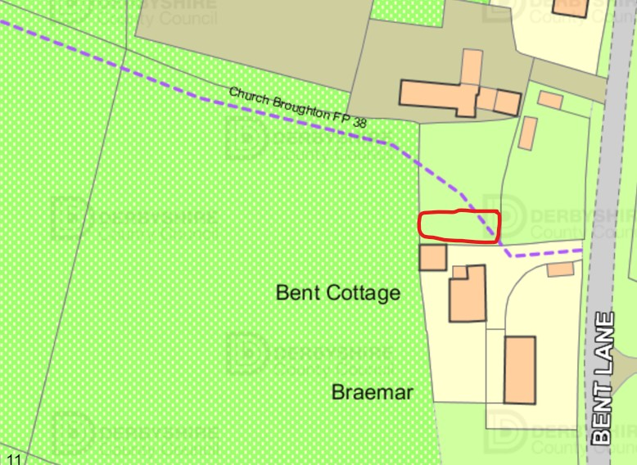

Councillor Warriner had walked local footpaths and made a record of where these have become blocked; repairs to stiles required; or replacement stiles installed. Councillor Warriner to circulate maps appropriately annotated where action is required. Councillor Warriner proposed that high amenity footpaths should be the focus of the Parish Council either by voluntary clearance or seeking help from landowners.
Councillor Woodhall reminded everyone that to maintain the goodwill of landowners it is best to speak with them first, asking their assistance to clear a blocked footpath or to repair a stile before any work is undertaken. If the landowner does not undertake the work, then we can report to the footpaths officer.
Councillor Woodhall updated Councillors on footpath 55 and explained that the landowner is in discussions with the footpaths officer to have the footpath diverted. The landowner had raised concerns over walkers leaving the footpath and crossing the farmyard. Councillor Woodhall will speak with the landowner and inform them that the footpath should be well sign posted to aid walkers and cause less stress for the landowner.

It had been noted that replacement footpath finger posts are being installed.

154.0 FINANCE

154.1 FINANCE REPORT
A finance report as at 1st March 2023 had been circulated.

154.2 CLERKS SALARY LESS TAX = £179.20
It was proposed by Councillor Woodhall and seconded by Councillor Speake to pay the Clerks salary. Cheque serial number 001341 issued.

154.3 CLERKS USE OF HOME £100
It was proposed by Councillor Speake and seconded by Councillor Woodhall to pay the Clerk for use of her home. Cheques serial number 001342 issued.

154.4 CLERKS EXPENSES £32.14
It was proposed by Councillor Woodhall and seconded by Councillor Speake to pay the Clerks expenses Cheque serial number 001343 issued.

154.5 D WALLIS LENGTHSMAN £60.80
It was proposed by Councillor Woodhall and seconded by Councillor Speake to pay the Mr Wallis. Cheque serial number 001344 issued.

154.6 B RUDGE LENGTHSMAN £34.64
It was proposed by Councillor Woodhall and seconded by Councillor Speake to pay Mr Rudge. Cheque serial number 001345 issued.

154.7 MAPMATIC - COMMUNITY HALL SURVEY - £810.00
It was proposed by Councillor Woodhall and seconded by Councillor Speake to pay Mapmatic. Cheque serial number 001346 issued.

154.8 A WALKER £125.00
It was proposed by Councillor Woodhall and seconded by Councillor Speake to pay the Mr Walker for hedge cutting. Cheque serial number 001347 issued.

154.9 A GUEST – FIRE RISK ASSESSMENT £250.00
It was proposed by Councillor Woodhall and seconded by Councillor Speake to pay Mr Guest. Cheque serial number 001348 issued.

154.10 SDDC EMPTYING LITTER & DOG BINS £1010.28
It was proposed by Councillor Woodhall and seconded by Councillor Speake to pay the Mr Walker for hedge cutting. Cheque serial number 001349 issued.

155.0 CORRESPONDENCE
None.

156.0 POLICIES
None.

157.0 CHAIRMANS NOTICES

157.1 ARE ALL EXISTING PARISH COUNCILLORS INTENDING TO STAND FOR RE-ELECTION IN MAY 2023
Councillors were reminded that Parish Council elections are due to take place in May and if they wish to stand again as a Parish Councillor they will have to re-apply for the position. All councillors indicated that they were willing. It was suggested Councillors may wish to meet to complete forms and hand deliver to SDDC

Clerk advised the following dates:
No later than 27th March publication of notice of election to be displayed.
By 4pm Tuesday 4th April, all nomination papers to be hand delivered to SDDC
No later than 4pm on Wednesday 5th April publication of statement of persons nominated to stand as Parish Councillors
No later than Tuesday 25th April publication of notice of election if required
Thursday 4th May polling day.
Annual Parish Council meeting to be held between 10th-25th May.

157.2 REVIEW & AGREE PROPOSED EMAIL TO PUBLICISE THE ELECTION
Councillors Pedley & Warriner had drafted a proposed notification to be issued to parishioners. All were in agreement with the wording of the document. Clerk to circulate. ACTION: CLERK

158.0 DATE & TIME OF NEXT MEETING
Thursday 6th April 2023 at 7pm.

Councillor Pedley to advise date of Annual Parish Meeting which it was suggested to hold prior to the end of April.

159.0 MEETING CLOSED
9.30pm

